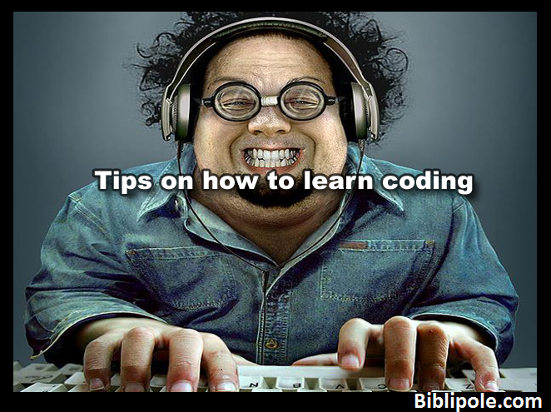

Simply watching a video or being attentive to a programming class won't cause you to skilled in programming. Here could be a list of tips for programming.

Don’t obtain books and waste cash attempt to Google it and watch videos on YouTube. Attempt to use PDF or eBooks offered on-line. Do not copy, paste the code attempt to kind it out. Examine the instance code after you learn writing, ensure you write it down on a paper or note it in your laptop Also Read: Is Learning To Code laborious? Don’t browse the code – run it forever have a backup of your programming files attempt to perceive the code Learn to use a program attempt to write

your own program once you learn it Code your program on UNIX system to urge higher expertise Experiment with changes of the code Also Read: a way to Delete Empty Folder With One Click attempt to decide one artificial language and learn it till the tip Learn basic programming languages like Python, Java, Html, C Learn the core ideas of the language specialise in one construct at a time Examine the syntax

HOW TO BECOME A GOOD PROGRAMMER:

1. **DECIDE YOUR GOAL**
2. **CHOOSE A PROGRAMMING LANGUAGE**
3. **MAKE LOVE WITH MATHEMATICS**
4. **BE SELF MOTIVATED**
5. **TAKE YOUR TIME**
6. **NEVER EVER BACK DOWN**
7. **BECOME A MASTER**
8. **BE A BOOK WORM**
9. **INVEST ON TRAINING CENTRES**
10. **TALK TO OTHER PROGRAMMERS**
11. **READ OTHER PROGRAMS**